The 3-tier Service Oriented Architecture

The scheduling application, after basic analysis, can be implemented in a 3-tier service oriented architecture as this section will describe.

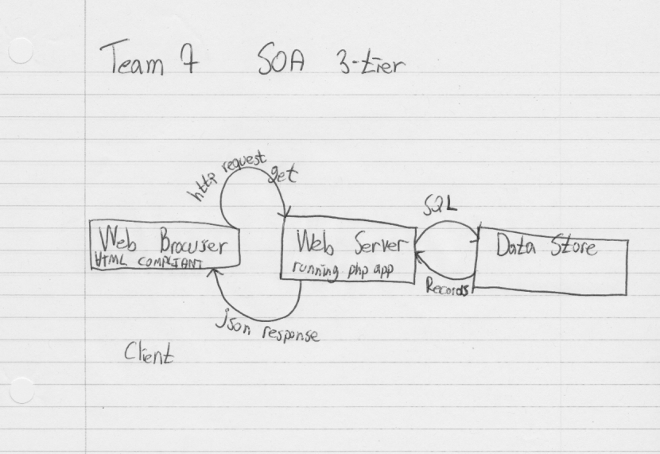

First Tier (Presentation)

The presentation tier is the topmost level of the application. This is where user interaction is to happen.

This application presentation layer, since we use a web-abb model, will be any browser that supports HTML 4.01, javascript and CSS should be able to access the scheduler. In the scope of the scheduler, IE 6+, Firefox 2.0+, Safari 3.0+, Opera 9.0+ and Chrome are all supported (and many more, for example, all browser running webkit and supporting javascript should be supported as Safari 3.0+ is supported and based on webkit)

The browser will basically make request to the second tier in order to obtain resources or consumes any of the services implemented in the scheduling system

While HTML and CSS will be the main presentation tools, Javascript will be used to glue responses from the server to the web page on screen. It is safe to assume that more than 95% of the visitors have javascript turned on and it is fairly standard by many other web apps to require javascript to be turned on in order to access whatever content they are offering. Source: [http://www.w3schools.com/browsers/browsers_stats.asp]

To assist in developing javascript, jQuery will be used to take away the burden of manipulating the Domain Object Model (DOM) and other cross-browser issues.

Second Tier (logic)

The second tier consist will contain business logic. This is decisions like does this course create a conflict are to be taken. It will also link the data tier with the presentation tier.

In this application it will be implemented as any capable web server running php.

Third Tier

The third tier can be any SQL compliant RDBMS that the second tier can interface with. It is going to receive SQL queries from the second tier and provide recordset that are to be transformed in JSON and passed to the first tier.

Relation between the tiers: Service Oriented Architecture (SOA)

The second-tier will answer first-tier query for either static document or service. It will uniquely get standard HTTP request containing:
- Cookies for session handling
- Resources to be sent / Service to be consumed
- Parameters in the form of GET or POST data depending on the service implied.

The response, when services are implied is to be encoded in the JSON format.

Here is a basic example of a service query and a JSON response.

Query:
Resource-> /getCurrentSchedule.php
Cookie: SessionID->SessionID

Response:
{
“courselisting”:
[
{
“coursename”:”MATH 205”,
“start”:”11:00”,
”stop”:”13:00”,
”room”:”H 365”
“weekdays”:”MT”
}

{
“coursename”:”SOEN 341”,
“start”:”10:00”,
”stop”:”15:00”,
”room”:”H 403”,
“weekdays”:”F”
}
]
}

Note that space and indentation have been added to ease reading and they are not important in constructing a valid JSON response. JSON is just a way of encoding a response, it is used by numerous web services like gmail, facebook or twitter and is appreciated by it’s human and machine ease of read as well as it’s low overhead resulting in faster response time [REQUIREMENT SPEED]

Also note that the course listing array mimics the database schema and that JSON encoder are widely available to turn a recordset obtained from a data store into a JSON string, easing even more the development. [REQUIREMENT CONSISTENCY ACROSS DB SCHEMA]

Such an approach derive unique benefits:
- Using this technique, we separate effectively presentation, logic and control effectively enforcing the MVC model. The PHP applications will never have to output HTML in such a request and only interface needs to be known by the UI Team and the Back-End Team.
- Such an abstraction enables the front-end team to code in parallel while the back-end is being developed by another team.
- New front-end can be easily developed to fit changing needs without any change required in the back-end. Third party tools/add-on can also be easily developed.
- Testing is eased since defined queries should yield defined output.
- Contracts for the interfaces can be directly mapped to each feature and can be known in advance, easing the development work again.

